**ZASLON-M MOBILE EXPLOSIVE DETECTOR**

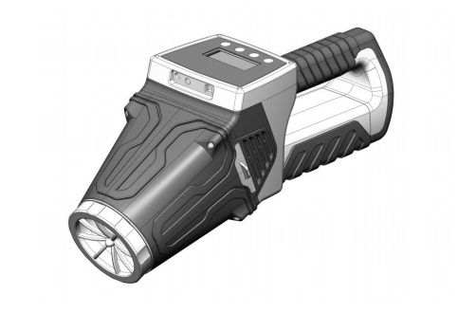

**OPERATION MANUAL**

**Moscow**

**Contents**

1. Product Operation....................................................................................................................................3

1.1 Purpose ............…………………………………………………………………………….…………………………………………………..3

1.2 Technical Characteristics (features) ...................................................................................................... 3

1.3 In Box .....................................................................................................................................................4

1.4 Design and Operation ........................................................................................................................... 4

1.5 Marking and Sealing…………………….……………………………………………………………………………………………........ 6

1.6 Package................................................................................................................................................. 6

2. Using the Product....................................................................................................................................6

2.1 Operational Restrictions....................................................................................................................... 6

2.2 Getting Started .................................................................................................................................... 6

2.3 Using the Product................................................................................................................................. 7

2.4 Operation in Extreme Conditions.........................................................................................................8

3 Technical Maintenance of the Product...................................................................................................8

4. Product Minor Repair ........................................................................................................................... 9

5. Storage .................................................................................................................................................10

6. Transportation ..................................................................................................................................... 10

7. Disposal ................................................................................................................................................10

This Operation Manual (OM) is intended for proper and safe operation of ZASLON-M mobile explosive detector TU 4215-002-82559889-17 (hereinafter referred to as 'product' or 'device') and the assessment of its technical condition when considering the necessity to send it for repair. Product maintenance does not require any special training of staff.

**1. PRODUCT OPERATION**

**1.1 Purpose**

1.1.1. ZASLON-M mobile explosive detector is intended for direct real-time detection of explosives, both indoors and outdoors, as well as trace amounts of nitro-containing explosives on hands, documents and other objects that were in contact with explosives provided temperature ranges are carefully maintained. The device also ensures measurement quality in the presence of foreign substances in the air.

**1.2 Technical Characteristics (Features)**

1.2.1 List of detectable substances: ammonium nitrate, dinitrotoluene, trinitrotoluene, trinitro-resorcinol (picric acid), dinitronaphthalene, dimetyldinitrobutane, ethylene-glycoldinitrate, nitroglycerin, tetranitropentaerytrite, pentaerythritetranitrate, hexogen, octogen, benzofuroxan, tri-peroxide acetone, hexamethylenetriperoxidediamine, industrial explosives based on hexogen (hexogen +plasticizer), industrial explosives based on octogen (octogen+plasticizer), simteks (hexogen+tetranitropentaerytrite+plasticizer), octol (hexogen+trinitrotoluene), ammonite, ammonal, nitropowder, etc.

1.2.2 Explosive vapours measurement limit at least TNT 10-11 g/cm3

1.2.3 Distance from the object under control while checking up to 250 mm

1.2.4 Power supply is provided the following ways: - from AC adapter with a frequency of 50/60 Hz, 100 - 240 V; - from a battery with an output voltage of at least 12 V.

1.2.5 Continuous operation time from a fully charged battery under normal climatic conditions is at least 8 h.

1.2.6 The product features the following functions and adjustments:

- low-pitched sound signal when detecting low vapor concentration;

- increased-pitched sound signal when detecting increased vapor concentration;

- high pitch signal when the detecting high vapor concentration;

- the option to connect to the PC via USB-connector;

- automatic shutdown of the device when the battery is low.

1.2.7 Detection time is no more than 2 seconds.

1.2.8 Time to enter operating mode after power-up is no more than 15 s.

1.2.9 Installation time (or closing-down, with placing in a standard packing) no more than 3 minutes.

1.2.10 Overall dimensions of the device are (410 ± 10) x (192 ± 10) x (140 ± 10) mm.

1.2.11 Weight of the device with batteries (2 ± 0,1) kg.

1.2.12 Climatic operating conditions:

- operating temperature range from minus 0 to plus 40 ° C;

- relative air humidity of not more than 85% at a temperature of plus 25 ° C ± 1 С.

**1.3. In Box**

1.3.1 Product Delivery Set is specified in Table 1.

Table 1

|  |  |  |
| --- | --- | --- |
| **Name** | **Pcs.** | **Note** |
| ZASLON-M Device | 1 |  |
| Photoluminescent Sensor Kit | 3 |  |
| Charger | 1 |  |
| Case | 1 |  |
| Shoulder Strap |  |  |
| Operation Manual | 1 |  |
| Package | 1 |  |

Notes

1. The rechargeable battery is supplied uncharged.

2. The charger and the case can be replaced by similar ones according to their technical specifications.

1.3.2. The main components of the device are shown in Figure 1

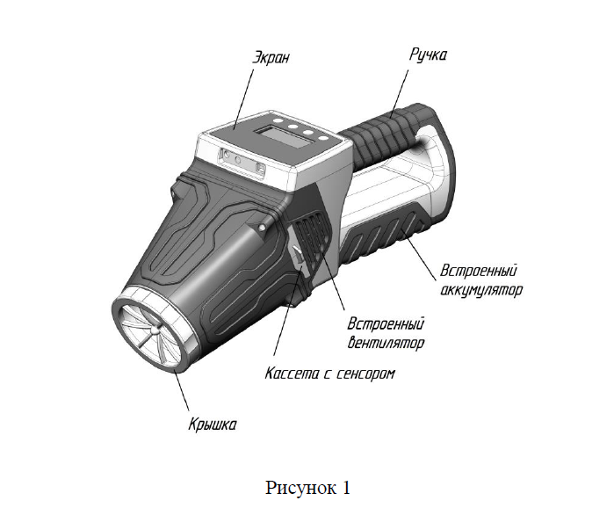

Figure 1

*Sensor cassette*

*Built-in fan*

*Built-in rechargeable battery*

*Lid*

*Handle*

*Display*

**1.4. Design and Operation.**

1.4.1. The main components of the device and the control layout are shown in Figure 2.



Figure 2

*Power ON/OFF button*

*Charger connector*

*Connector for interface cable*

*ENTER to confirm the selected menu item and quit submenu*

*Headphones connector*

*UP navigation button*

*DOWN navigation button*

1.4.2 The operation principle of the device is based on the quenching of photoluminescence of the sensor material in the presence of explosive vapors. The built-in air pump and the design of the device provide swirling air flow that ensures a steady intake of air at a distance of up to 250 mm from the object under control. The explosive detect technology is embedded in the system and allows measurements, both indoors and outdoors, provided temperature conditions are met as specified in technical characteristics of the device. At the same time, the quality of the measurements is not affected by the operation of the ventilation systems, as well as air circulation in the area of ​​the surveyed objects. Moreover the quality of measurements is not affected by the foreign smells of such substances as gasoline, kerosene, tobacco, perfume and other smells not containing explosives.

1.4.3 The operation modes of the device are controlled using the four buttons shown in Figure 3:



Figure 3

- ENTER to confirm the selected menu item and quit submenu

- UP and DOWN for menu navigation

- POWER Button

1.4.4 Scope of application

- monitoring of explosives vapor content in the air of enterprise workspace;

- border and customs check points;

- defence facilities;

-security of mass events;

- transport security;

- use by law enforcement bodies;

- prevention of terrorist attacks with explosives use.

**1.5. Marking and Sealing.**

1.5.1. Marking of the product, which includes short name of the manufacturer, individual serial number, part number and year of manufacture is marked on the code plate on the case of the device and on the package (case). The case with the product is packed in a cardboard box.

1.5.2. The product is sealed (if needed) on a standard package (case). The product itself is not sealed.

**1.6. Package**

1.6.1. The product is packed in a standard package (case).

1.6.2. The product in a standard package is packed in a matched transport packaging (cardboard box).

**2. USING THE PRODUCT**

**2.1. Operational restrictions**

2.1.1. Before starting, carefully read this Operation Manual

2.1.2 When finished, power off the device to prevent battery discharge during transportation and storage.

2.1.3. Do not disassemble the device or repair it by the operating organization. Contact the manufacturer if any malfunctions in the operation of the device have been detected.

2.1.4 Attention! When installing the sensor, hold it only by the plastic edges and do not touch the surface of the sensor material.

2.1.5. Do not immerse the product into water, do not power the product in case of water ingress, do not operate the product at temperatures beyond the limits specified in p. 1.2.21.

2.1.6 Do not use other chargers to charge the product, since their use can lead to the device failure.

2.1.7 Do not store the device at temperatures above plus 50 ºС, for example, in a car left in the sun.

2.1.8 It is recommended to charge the battery at an ambient temperature ranging from plus 10 to plus 30 ºС.

2.1.9 Do not turn on the charger outdoors when exposed to rain or high humidity over 85%.

2.1.10 Do not leave the sensor in the device, if there are no measurements being taken.

**2.2. Getting Started**

2.2.1. Before using the device, make sure there is no violation of operational restrictions specified in p. 2.1.

2.2.2 Unpack the device and the photoluminescent sensor

2.2.3 If the device is not charged, charge it using a charger.

2.2.4 To charge the device, remember the following:

- it is not necessary to discharge the battery before charging, since residual charge of the battery does not affect its nominal capacity;

- recommended ambient temperature when charging should be in the range from plus 10 to plus 30 ºС;

- the battery should be charged on a flat surface without vibration;

- while charging, the charger may get warm, which is normal.

2.2.5 Check the integrity of the sensor package, open the package and install the sensor into the cassette according to Figure 4, with the open surface of the sensor up. When installing the sensor, hold it only by the plastic edges, and do not touch the surface of the sensor material.

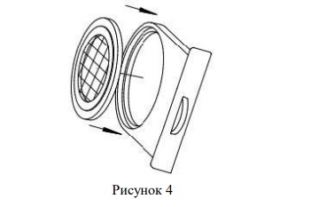

Figure 4

2.2.6 Insert the cassette with the sensor into the case of the device according to Figure 5.

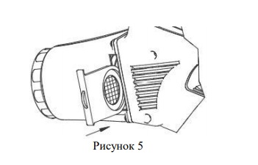

Figure 5

**2.3 Using the Product**

**2.3.1 Safety measures when using the product**

2.3.1. Do not leave the sensor in contact with objects containing explosives, that will lead to its premature failure.

2.3.2 Do not connect any other interface cables to the device or connect it to any computer devices.

**2.3.2 Using the Product**

2.3.2.1 To start operating the product, perform the following (see Figure 2 and Figure 3):

- enable the device by holding the power button for about 2 s;

- for correct operation of the device, it needs to be calibrated. Select CALIBRATION option in the menu using menu navigation buttons. Confirm item selection with the confirmation button. Calibration process will take no more than 5 s. A failed calibration message indicates a missing sensor element.

- select START option in the menu using navigation buttons the option. Confirm item selection with the confirmation button. Measurement results are updated once per second.

With a small concentration of explosive vapors, there appear ATTENTION message and a low tone sound. With an increased concentration of explosives vapors, there appear DANGER message and a increased-pitched sound. At high concentrations of explosive vapors, there appear HIGH DANGER message and a high tone sound.

- to turn off the device, select EXIT option in the menu using navigation buttons. Confirm item selection with the confirmation button.

2.3.2.2 The device is equipped with a set of photoluminescent sensors. After measurement, remove the sensor from the cassette, place it in the original plastic container and store it in a dark place. After opening the original packaging, the sensor is suitable for measuring no more than thirty days of daily work. The sensor must be replaced after fifty cases of explosives detection. When stored in a sealed factory package, the sensor is fit for service for up to 3 months. The used sensors must be returned to the factory supplier for disposal and stored in their original plastic container, with a note on the reason of sensor failure (10 detection cases or 30 measurements sessions). To monitor sensor performance, it is recommended to maintain data log on the cases of explosives detection.

2.3.2.3 USB-connector is designed to connect the device to the PC via interface cable and output data for setting / reconfiguring and determining the quality of sensors only by a qualified manufacturer as part of warranty service.

**2.4. Operation in extreme conditions.**

2.4.1. In case of fire on the device, power off the device and take measures to put out fire.

2.4.2. In case of emergency operating conditions (high temperature, humidity, vibration, etc.), take measures to reduce the impact of emergency factors on the product.

**3. TECHNICAL MAINTENANCE OF THE PRODUCT**

3.1. Product maintenance does not require special training of staff.

3.2 When finished, open air intake lid, carefully remove the helix and wipe the surface of the helix as well as 'A' surface with a damp, clean cotton cloth according to Figure 6.

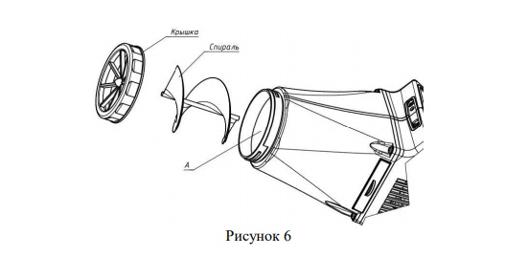

Lid

Spiral

Figure 6

3.3. Optical surfaces of the device (display) when dirty should be cleaned only with a clean cloth made of genuine or microfiber suede, designed for cleaning optical parts (eg glasses). Before that blow away the grains of sand and dust. To remove heavy grease, use a cotton swab moistened in ethanol, having preliminary removed solids from the optics with a soft brush.

3.4. Product functional testing and its technical inspection is controlled by checking paragraphs 1.2.6, 1.2.7.

3.5. Preservation (degreasing, reconservation) of the product is carried out by packing it in its standard package (plastic case).

**4. PRODUCT MINOR REPAIR**

4.1. Minor repair of the product is carried in accordance with Table 2.

Table 2

|  |  |  |
| --- | --- | --- |
| **Failure and damage consequences** | **Possible Reasons** | **Troubleshooting** |
| Device does not turn on | Discharged battery  Battery failure | Charge the battery  Contact the manufacturer |
| Calibration failed | The sensor is worn out or missing in the cassette. Incorrect calibration activation. | Install sensor or replace it by a new one.  Enable calibration again. |

Note - If measures to eliminate failures listed in the table do not allow restoring the product to its operability, it should be directed over to the manufacturer for repair.

**5. STORAGE**

5.1. Storage conditions.

5.1.1. The device must be stored packed (in case) on the shelves in the capital heated rooms at temperature from 5 ° C to + 40 ° C and a relative humidity of 80% at temperature of +25 ° C at no vapors of acids, alkalis, current-conducting dust and other chemically active substances, gases that cause corrosion and destroy insulation. It can be stored in a standard package when stacked (horizontally) on the shelves with up to 4 products. Stacking in a vertical position is not allowed.

5.2. Storage life

5.2.1. Storage life of the product in a standard package is 1 year in heated ventilated premises at ambient temperature from + 50С to + 400С and a relative humidity of up to 80% at temperature of 25 ° C.

5.3. Terms of placing the product in storage and withdrawing it from storage.

5.3.1. When placing the product for storage, pack it in standard package and place on the corresponding cells. When withdrawing it from storage, the components of the product should be removed from the package and kept under standard climatic conditions (ambient temperature 20 ± 5°C, relative humidity from 45 to 80%, atmospheric pressure from 8.6 • 104 to 10.7 • 104 Pa), for at least 12 hours.

**6. TRANSPORTATION**

6.1. Requirements for transportation and transportation conditions.

6.1.1. Transportation of the device is carried out in a transport container by all kinds of goods and passenger transport at a height of up to 12,000 meters at ambient temperatures from 0 ° C to + 50 ° C and protected against direct exposure of precipitation and reactive components. When carried in railway wagons, the shipment should be small low-tonnage. After transportation and before using, keep the product in standard climatic conditions for at least 12 hours.

6.2. The procedure to prepare the product for transportation and methods of attachment during transportation**.**

6.2.1. Before transporting the product in a standard package, it can be packed into an extra matched shipping container (carton or plywood box). Products in transport containers should be secured in such a way as to ensure the stability of their position, excluding mutual displacement and strokes. During loading, unloading and transporting, the requirements of handling marks on the shipping container must be strictly observed.

**7. DISPOSAL**

7.1 Product disposal must comply with environmental standards.

7.2 The batteries used in the product, after the end of life (or failure), must be disposed at a specialized enterprise in the prescribed manner.

  7.3. Arrangements for preparation and shipment of the product for recycling include disassembly, disassembly into components and parts with homogeneous materials.

7.4. Materials are sent for recycling in the order established by the consumer.